Speech Spectrogram

• Sound intensity versus time and frequency

Wideband spectrogram

• Spectral analysis on 15 msec sections of waveform using a broad (125 Hz) bandwidth sections of waveform using a broad bandwidth analysis filter, with new analyzes every 1 msec

• Spectral intensity resolves individual periods of the speech and shows vertical lines during voiced regions

Narrowband spectrogram

• Spectral analysis on 50 msec sections of waveform using a narrow (40 Hz) bandwidth analysis filter with new analyzes every 1 msec

• Narrowband spectrogram resolves individual pitch harmonics and shows horizontal lines during voiced regions

Wideband vs Narrowband

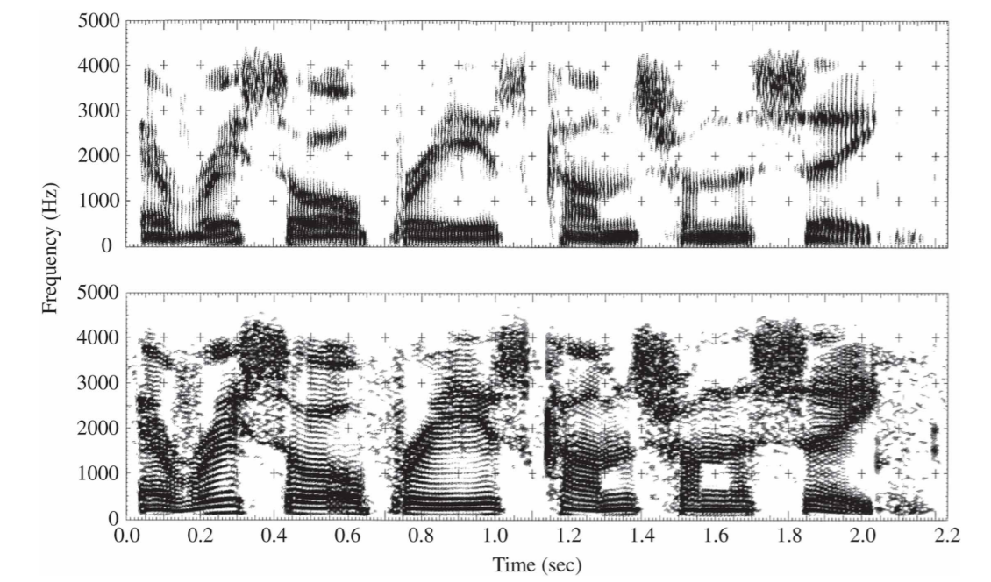

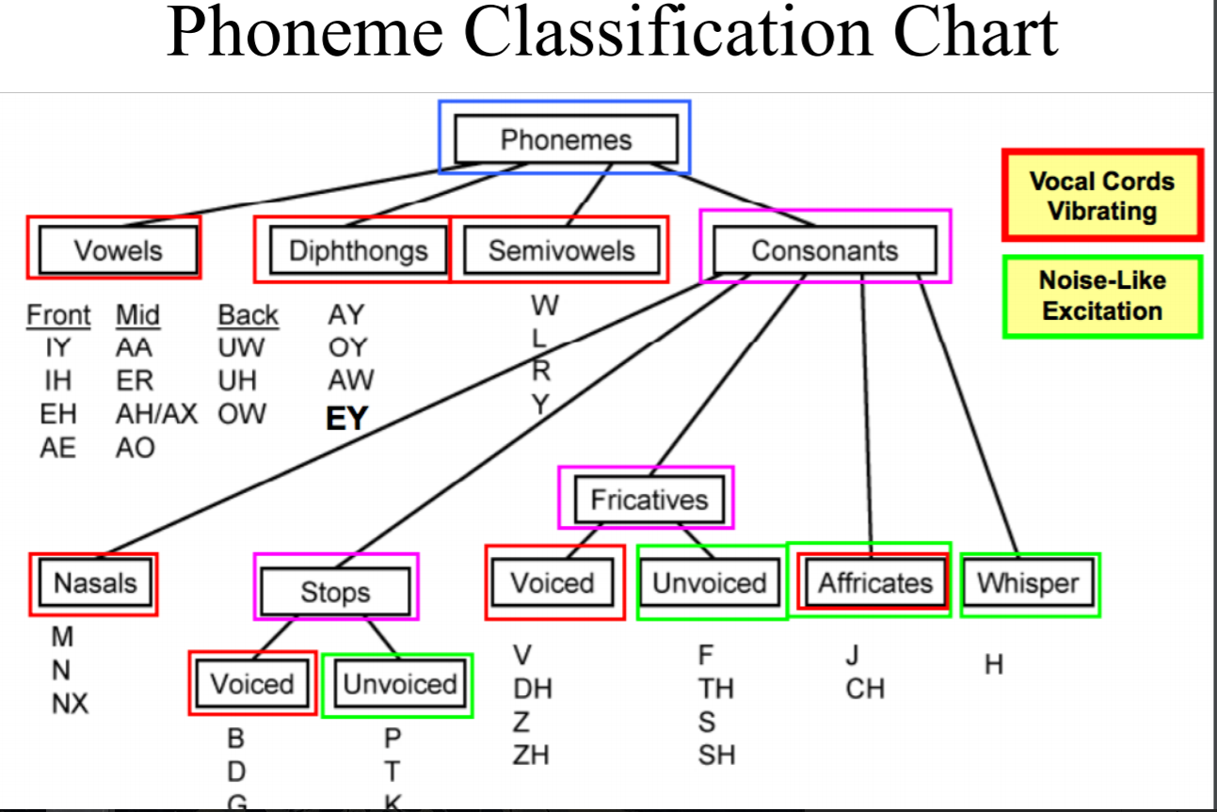

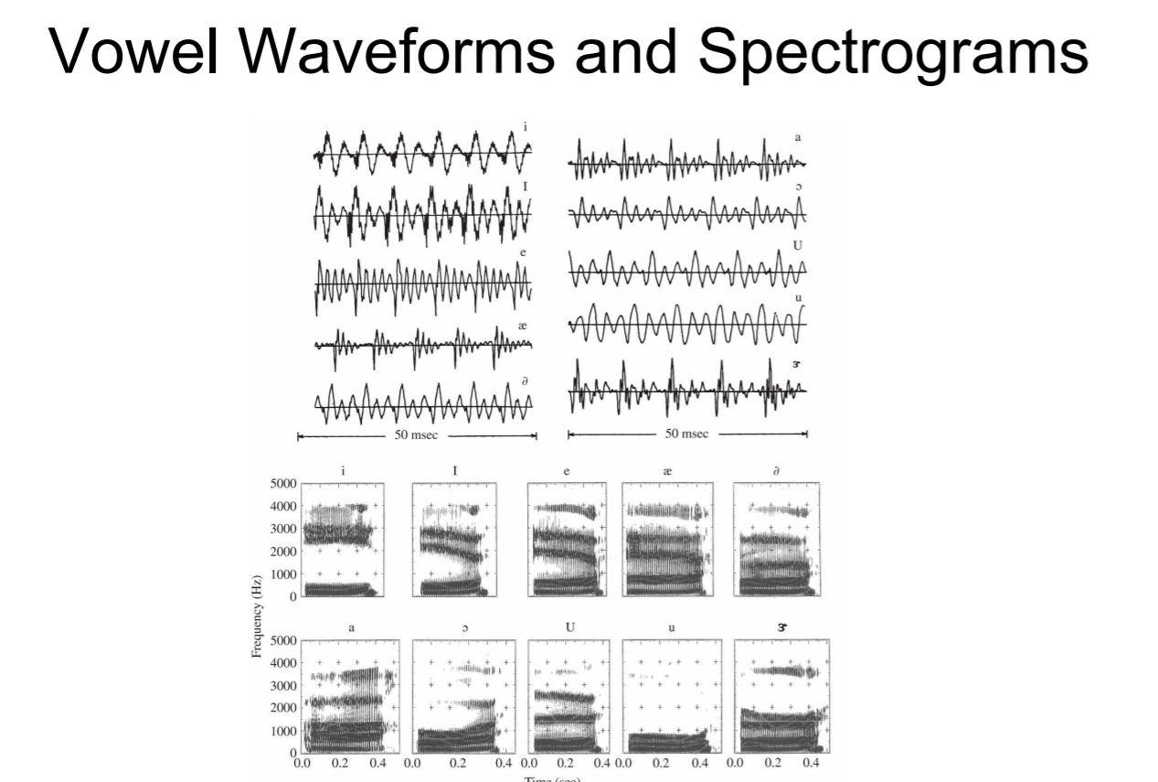

Diphthongs

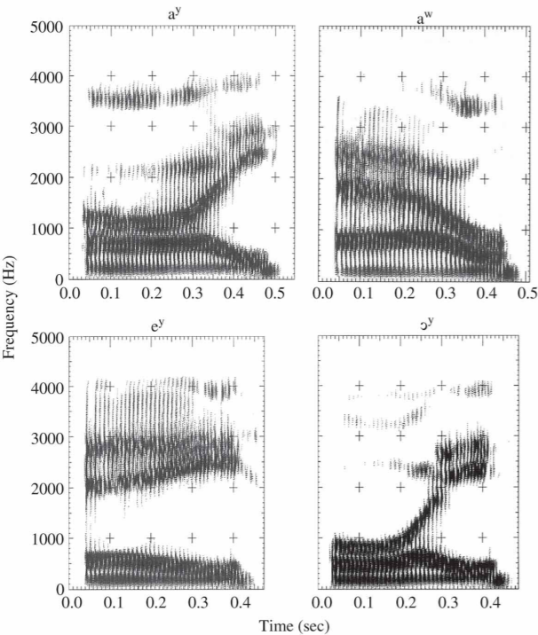

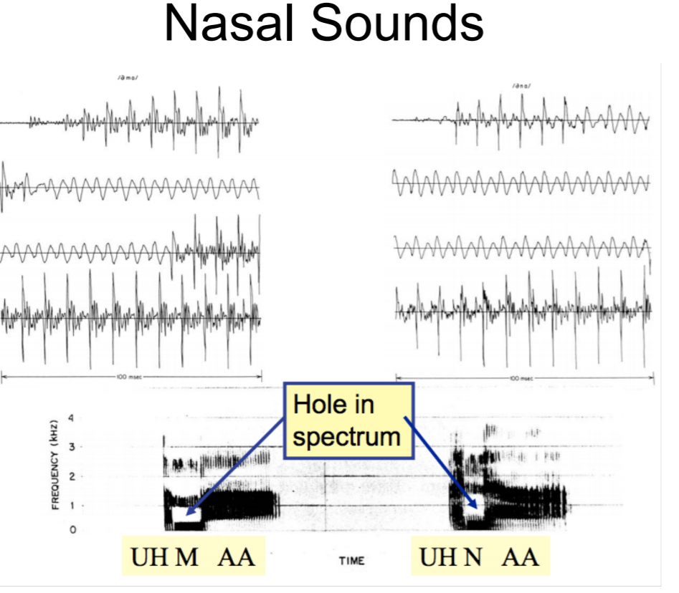

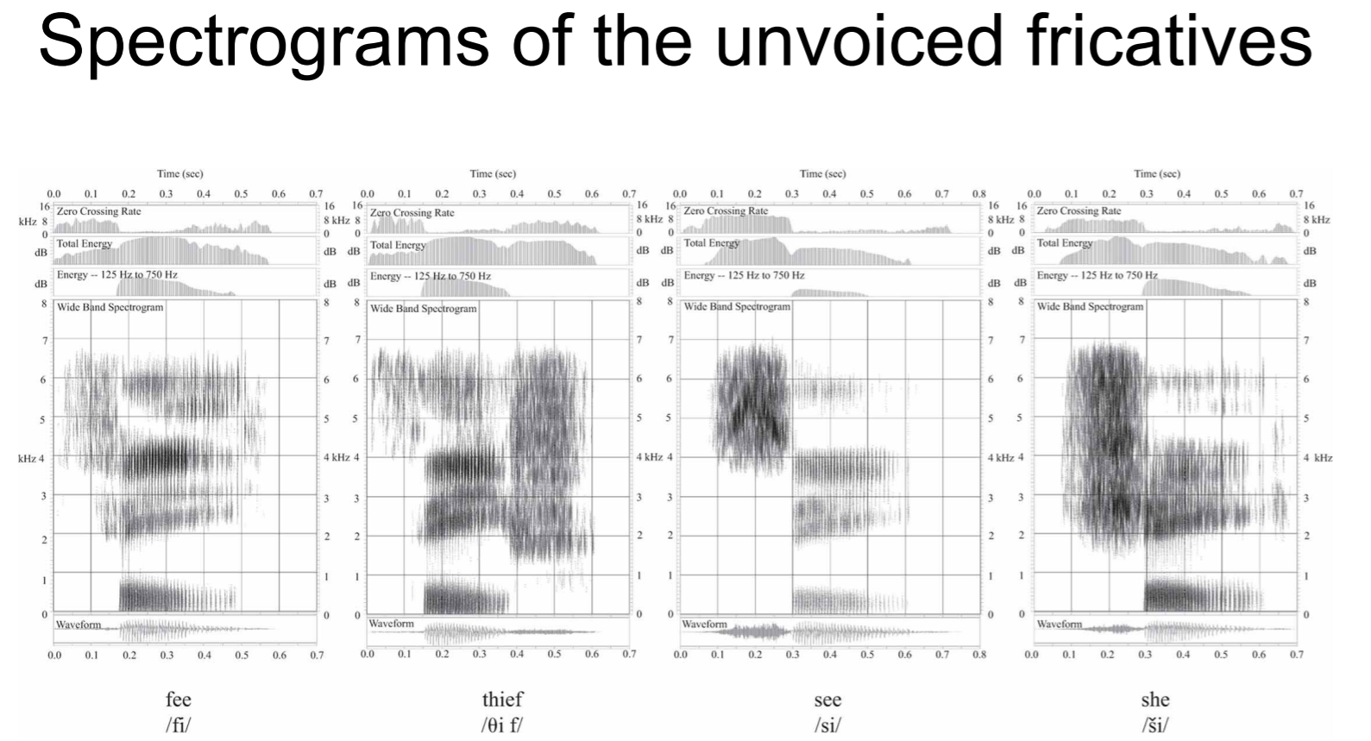

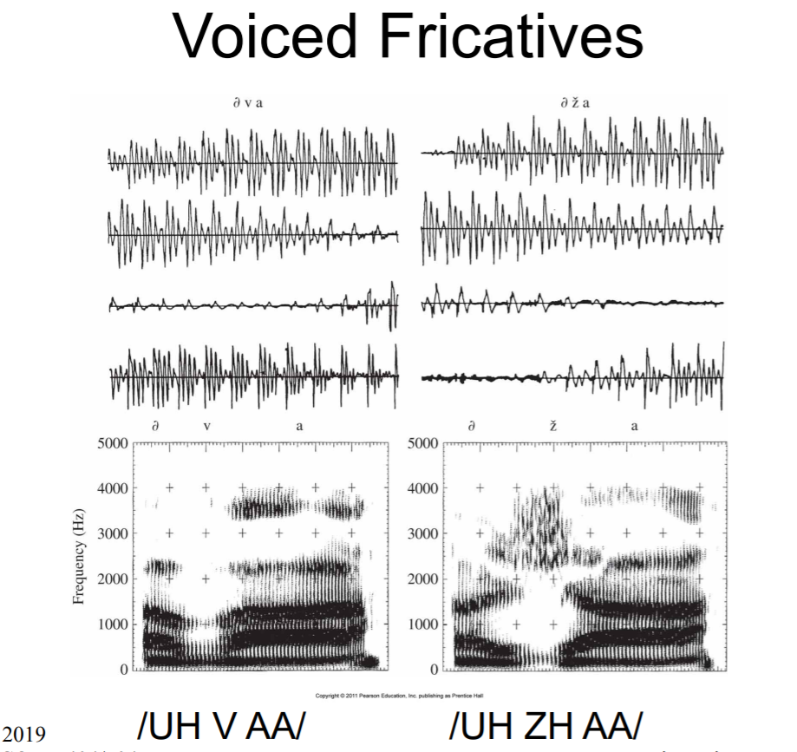

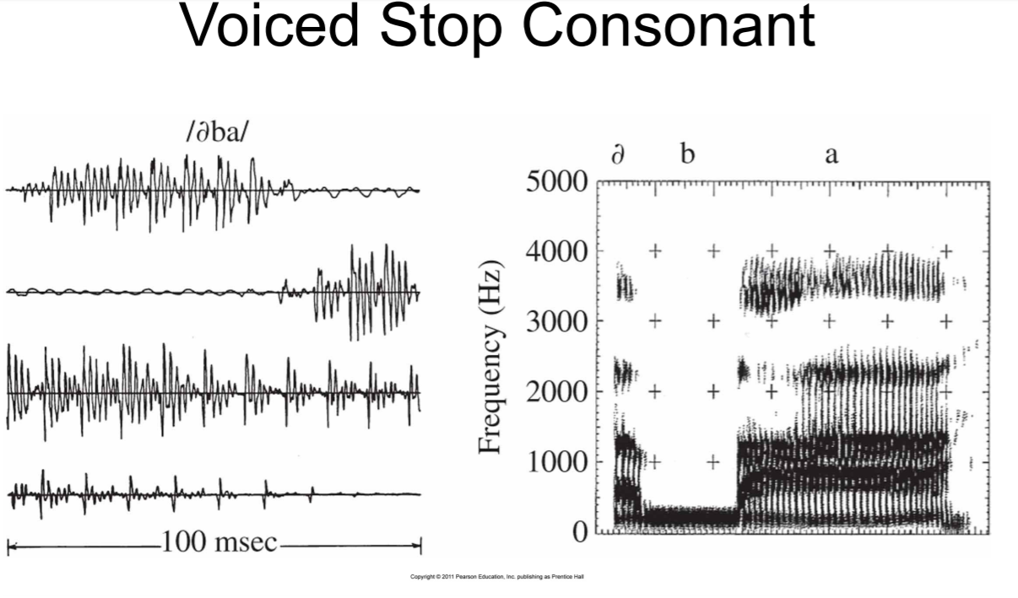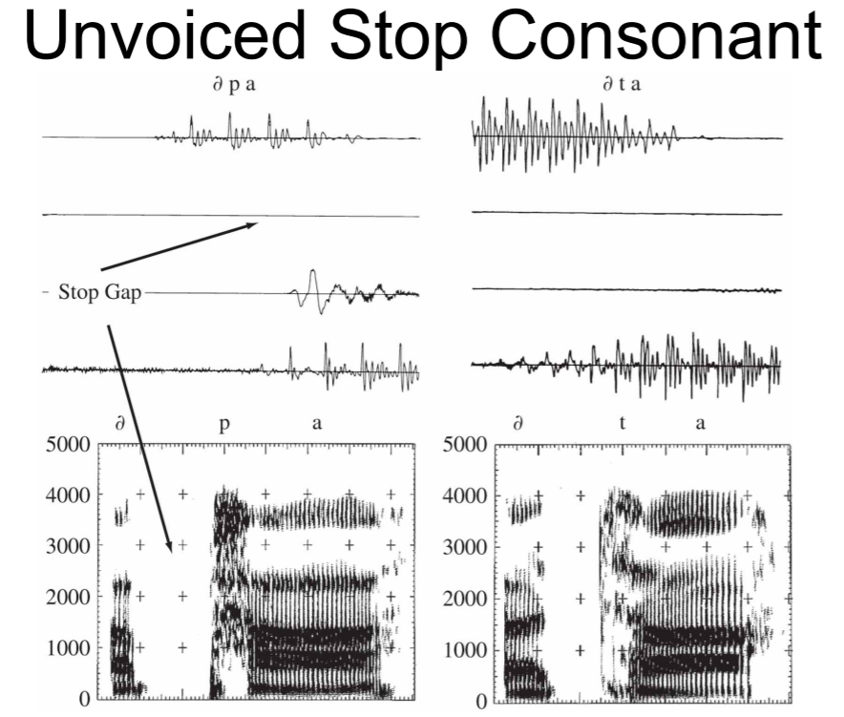

----------o----------

Sound Intensity

Threshold of hearing defined to be: I0 = 10^-12 watts/m2

• The intensity level of a sound: IL = 10 log10(I/I0) dB

For sinusoidal input with amplitude P, intensity is proportional to P^2 and the sound pressure level (SPL) is defined as:

• SPL = 10log10(P^2/P0^2) = 20log10(P/P0) dB where P0 = 2x10-5 Newtons/m2

Loudness: sounds with equal intensities but different frequencies are perceived by the same person to  
have unequal loudness

• A 60 dB sound with a frequency of 1000 Hz sounds louder than a 60 dB sound with a frequency of 500 Hz

• The unit phon is defined for the perception of loudness 1 phon is equivalent to 1 dB at 1000 Hz (1 kHz)

At 1 kHz, LL = IL = 10 log10(I/I0) = 10 log10(I) + 120

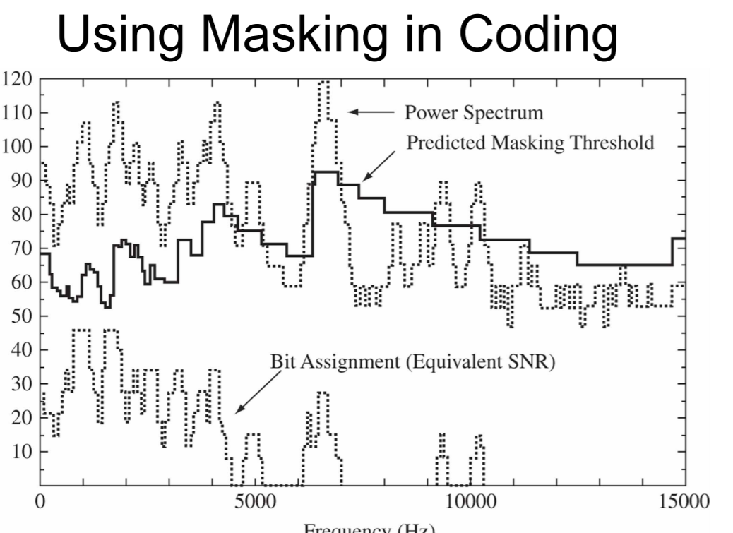

Pitch is the perceptual quantity that is related to the fundamental frequency

• 1000 Hz ≡ 1000 mels

One critical bandwidth corresponds to about 100 mels on the subjective pitch scale

The auditory system performs a frequency analysis that can be simulated with a bank of bandpass filters whose bandwidths increase as center frequency increases

_____________________________________________________________________________________

**DSP Review**  
1/T = Fs >= 2*fmax -> sampling theorem

***- Z-transform***

X(z) = sum_infinity( x[n] * z^-n)

x[n] = 1/(2pi*j) * integral (X(z) * z^(n-1) * dz)

***- Discrete Time FT***

X(e^jw) = sum_infinity(x[n] * e^-jwn )

x[n] = 1/2pi * integral( X(e^jw)*e^jwn*dw)

Parseval’s theorem : 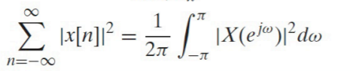

- ***DFT*** – x[n] must be periodic with N.

X[k] = sum_0_N-1(x[n]*e^(-j2pikn/N))

x[n] = 1/N * sum_0_N-1(X[k]*e^(j2pikn/N))

z = e^jw = e^j2pik/N 🡪 equivalences among transformations.

Summary of Filtering

• Digital filtering provides a convenient way of processing signals in the time and frequency domains

• Can approximate arbitrary spectral characteristics via either IIR or FIR filters, with various levels of approximation

___________O___________

**Signal Processing in Time Domain**

Single Tube Model

To find formant frequencies: 🡪 n = 1, 2, 3 & $f_{n}=\frac{c}{λ_{n}}$

Two-tube model is used for real life cases. Its formula involves reflection coefficients (from glottis and lips) and is very complicated.

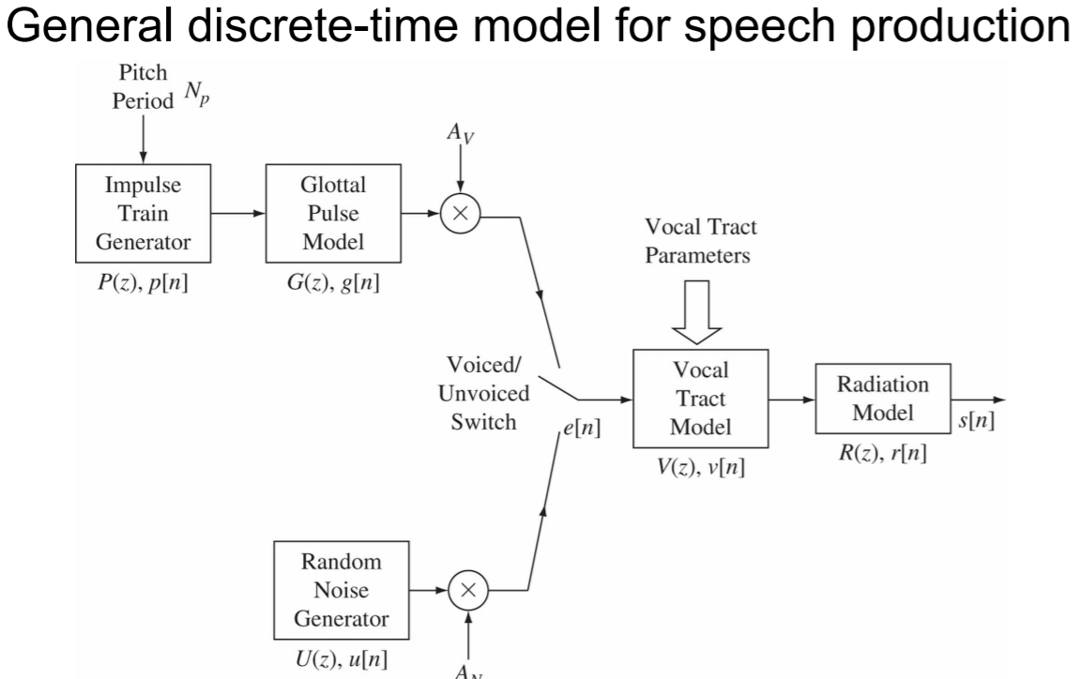

Short-time Processing

Short-time processing of sounds is periodically repeated for the duration of the waveform   
• These short analysis segments, or “analysis frames” almost always overlap one another

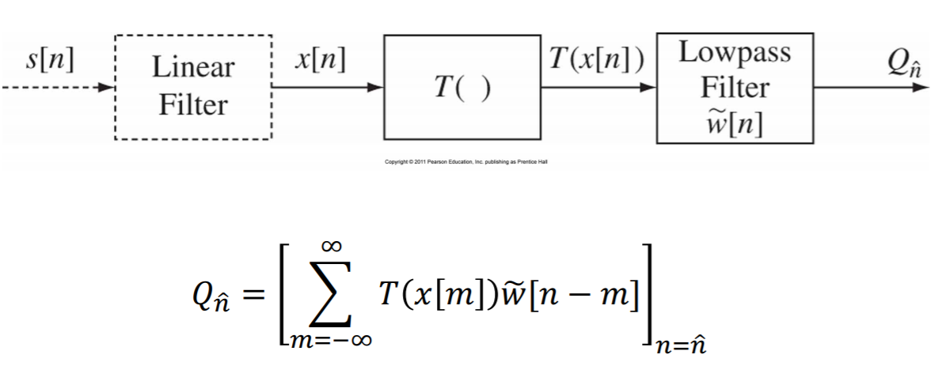

Short-time Energy:

🡪

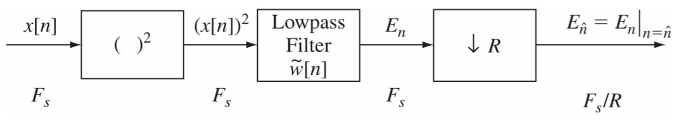

Window duration (frame length), L needs to be larger than a pitch period (or severe fluctuations will occur in En), but smaller than a sound duration (or En will not adequately reflect the changes in the speech signal)

$$E_{\tilde{n}}= \sum_{m= -∞}^{∞}{(x[m]}*w(n-m))^2$$

$$E_{\tilde{n}}= \sum_{m= -∞}^{∞}{x^{2}[m]}*w'(n-m)$$

Short-time Magnitude:

$$M_{\tilde{n}}= \sum_{m= -inf}^{inf}{\left|x\left[m\right]\right|w'[n-m]}$$

Short-time Average Zero-crossing Rate: Sinusoid at frequency F0 with sampling rate FS has FS/F0 samples per cycle with two zero crossings per cycle, giving an average zero crossing rate of 2.

Adding an offset might change the ZC rate (especially for noise signals).

$$Z_{n}=\frac{1}{2L}\sum_{m= n-L+1}^{n}{|sgn\left(x\left[m\right]\right)-sgn\left(x\left[m-1\right]\right)|*w'[n-m]}$$

It is sort of inversely proportional to st energy.

Short-time Autocorrelation:

Autocorrelation function for random signals is; $ϕ[k]=\lim_{L→∞}{\frac{1}{2L+1}* \sum_{m=-L}^{L}{x\left[m\right]*x[m+k]}}$

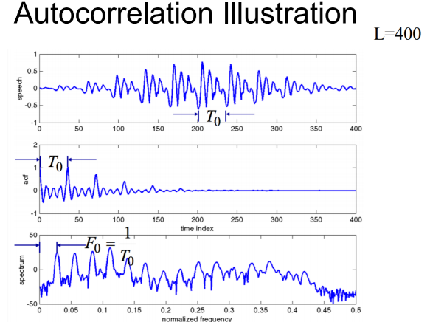Properties

• If $x\left[n\right]=x[n+P]$, then $ϕ\left[k\right]= ϕ[k+P]$

• $ϕ[k]$ is even, $ϕ\left[k\right]= ϕ[-k]$

• $ϕ[k]$ is maximum at k = 0

• $ϕ[0]$ is the signal energy or power for random signals

$R_{n}[k]={ \sum_{m=-∞}^{∞}{x\left[m\right]*w\left[n-m\right]*x[m+k]*w[n-m-k]}}$

${w'}_{k}\left[n\right]= w\left[n\right]*w[n+k]$

$R_{n}[k]={ \sum_{m=-∞}^{∞}{x\left[m\right]*x[m-k]*{w'}_{k}[n-m]}}$

Modified Short-time Autocorrelation: R’ is not symmetric, it is cross-correlation.

${R'}_{n}[k]={ \sum_{m=-∞}^{∞}{x\left[m\right]*w_{1}\left[n-m\right]*x[m+k]*w_{2}[n-m-k]}}$ for $w_{1}[m]=1$, $0≤m≤L$ and

$w_{2}\left[m\right]=1$, $0≤m≤L+K$

${R'}_{n}[k]={ \sum_{m=0}^{L-1}{x\left[n+m\right]*x[n+m-k]}}$ for $0≤k≤K$

Short-time Fourier Transform:

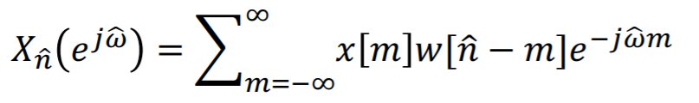

2 interpretations:

1. Assume n is fixed, STFT is simply the Fourier transform of the sequence x[m]w[n-m]

2. Assume W is fixed, then STFT is in the form of convolution of the signal x[n]e^jWn with the window w[n]

Properties of STFT

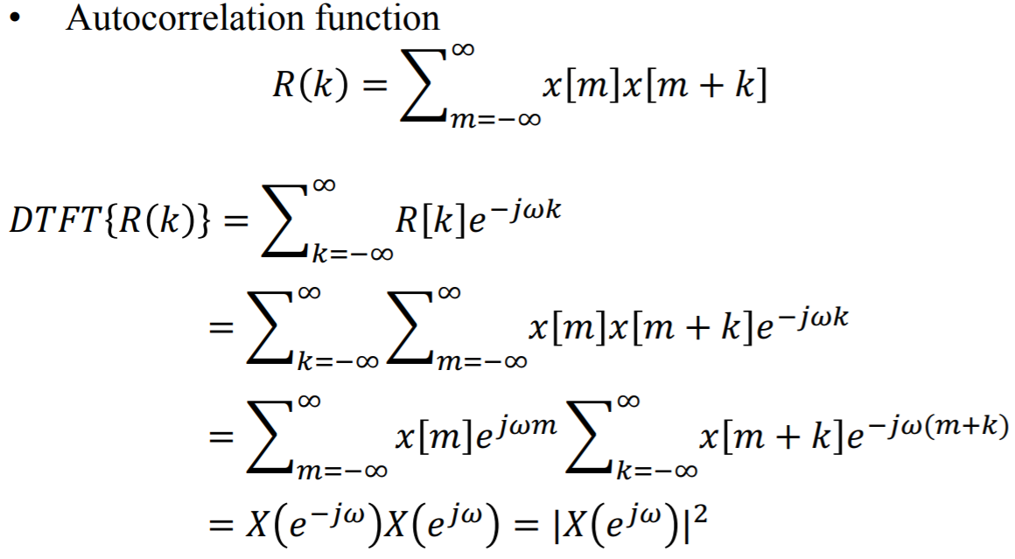

-

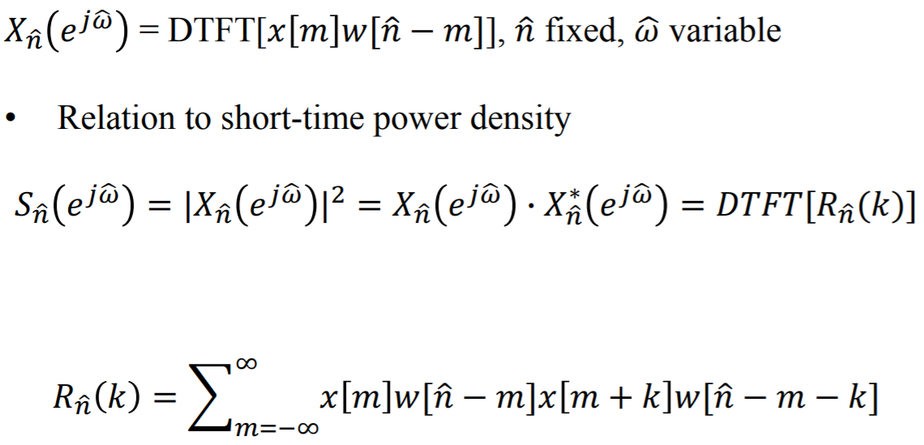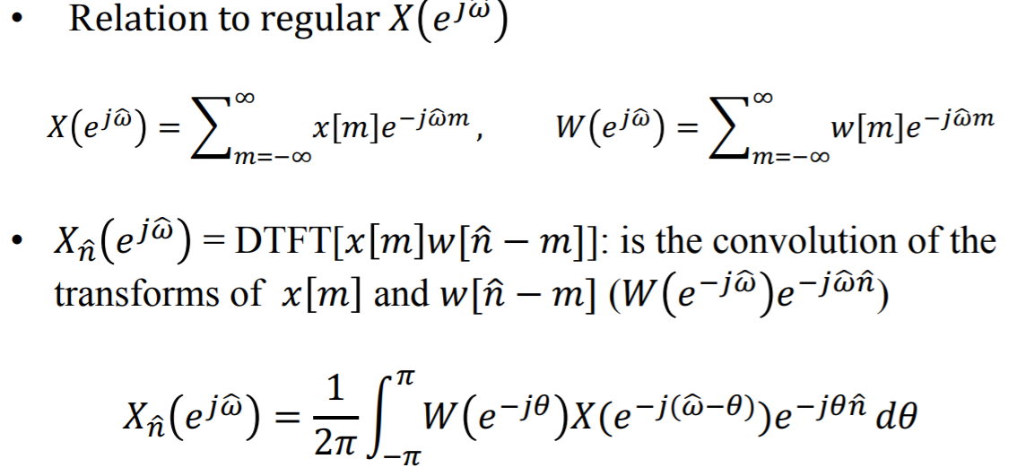

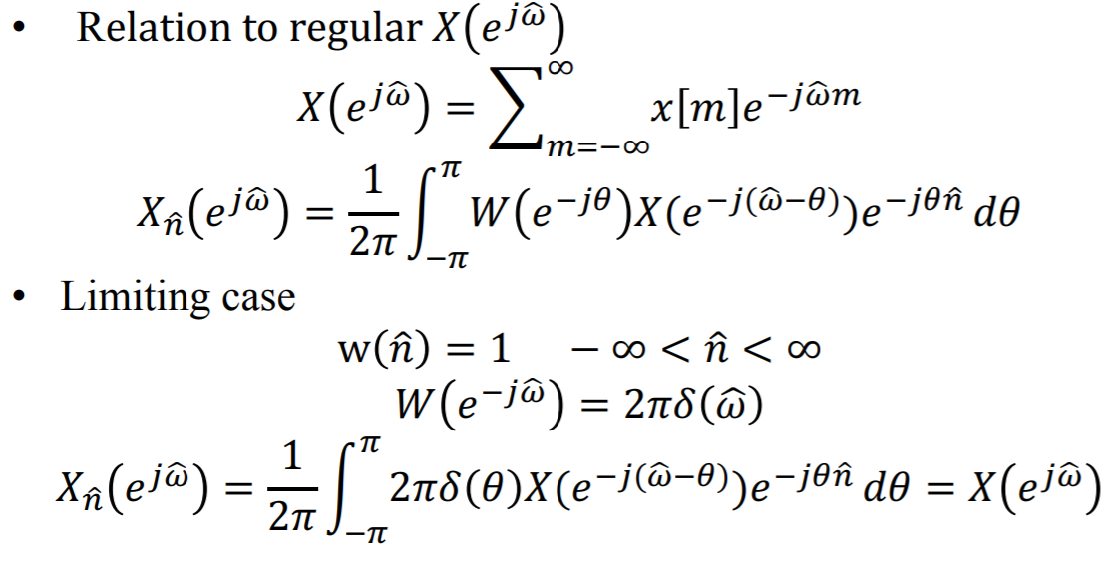

-is a smoothed version of the FT of the part of x[n] that is within the window w.

As window length decreases, bandwidth increases. This increases the resolution of spectrogram of STFTs

-------------O-------------  
**Linear Predictive Coding**

Basic Assumption of LPC  
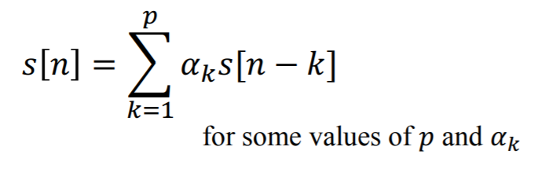

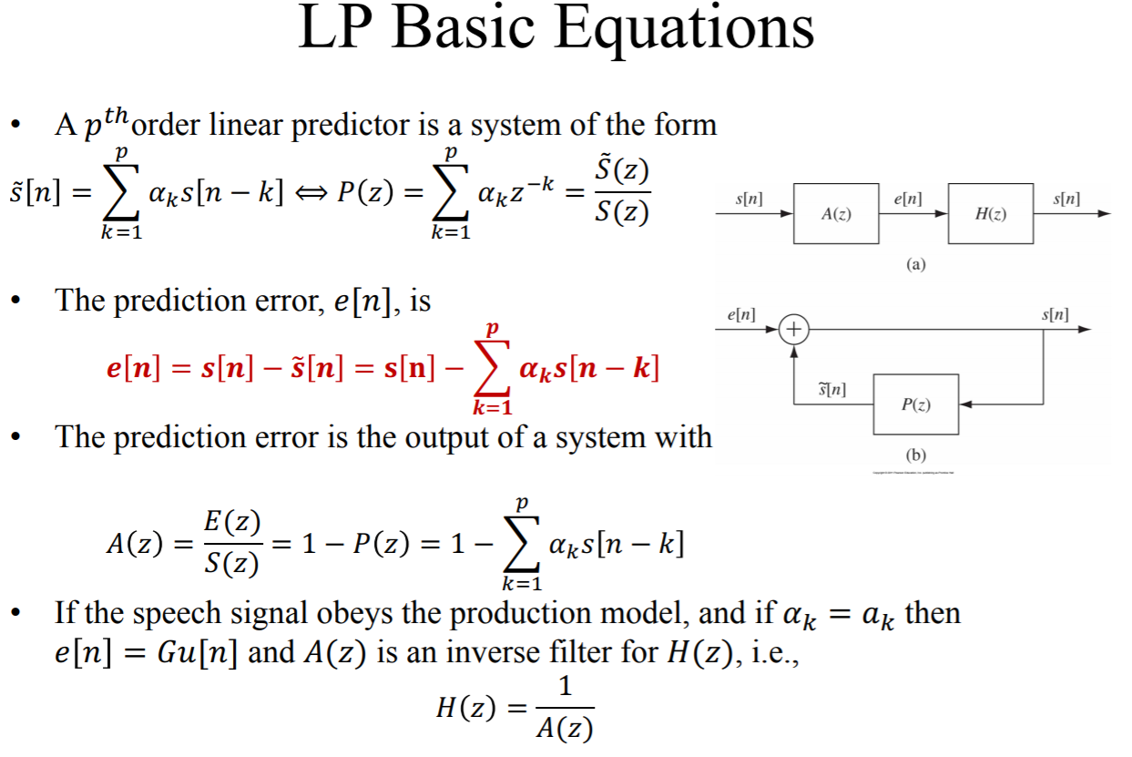

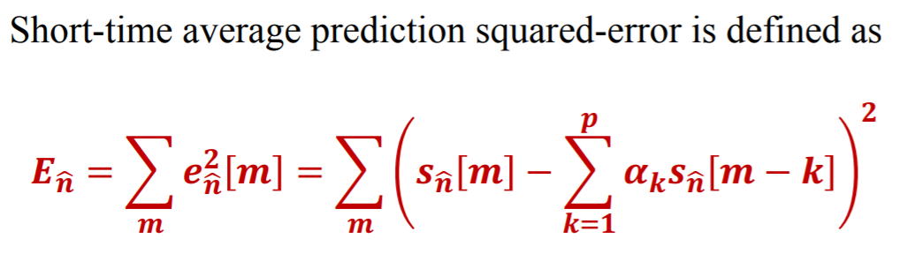

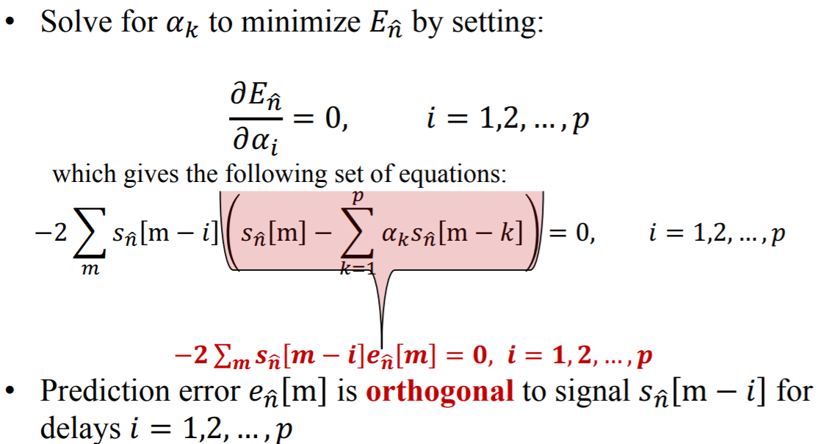

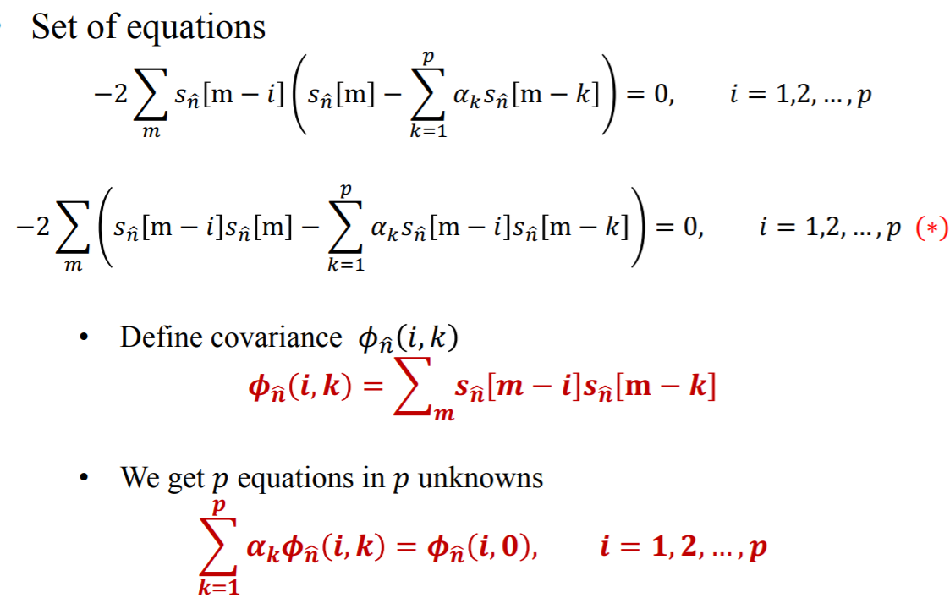

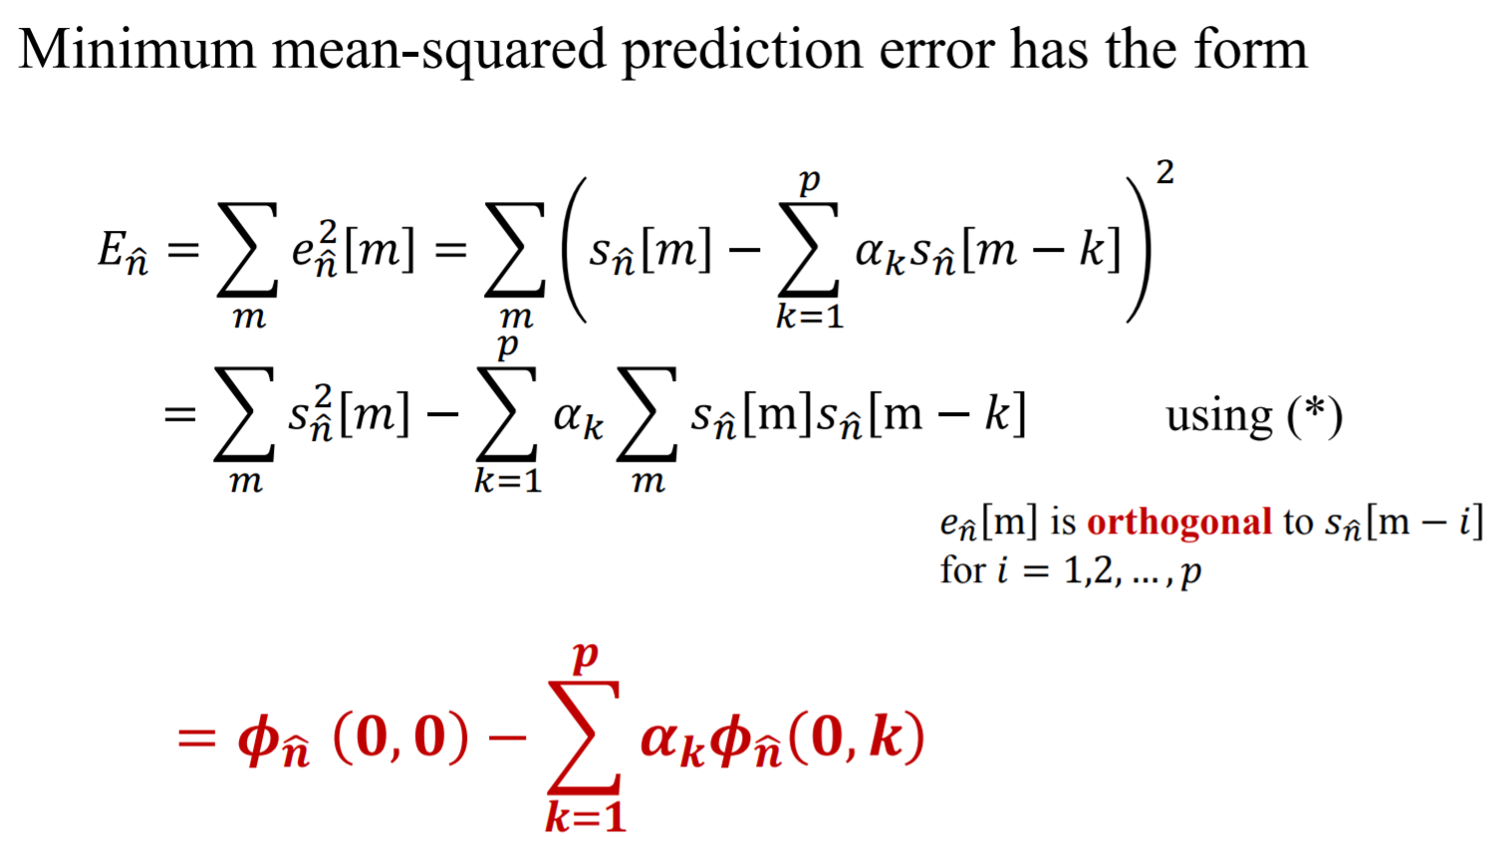



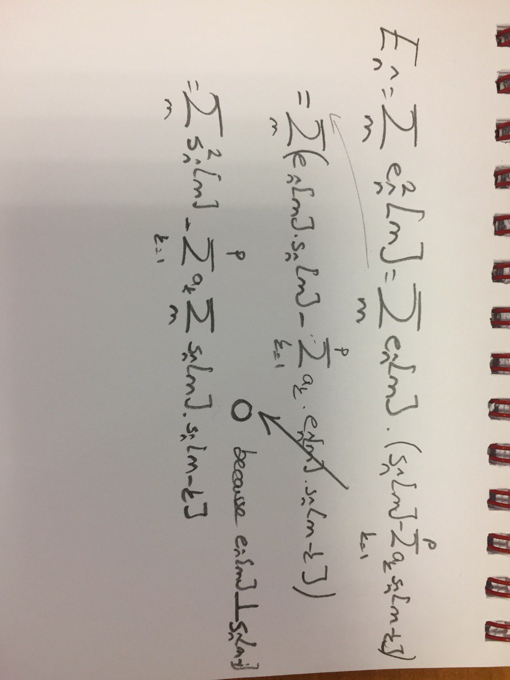



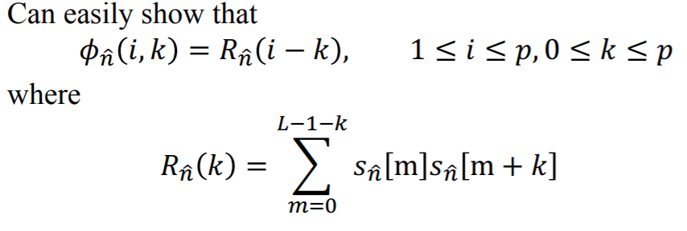

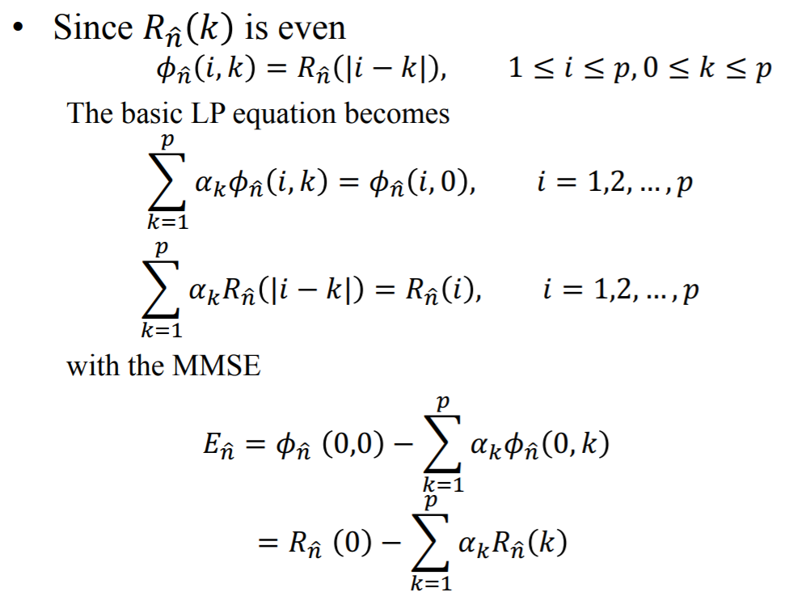

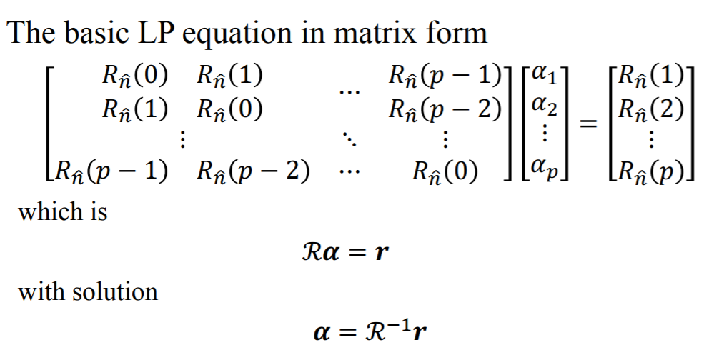

ℛ is a p×p Toeplitz Matrix: Symmetric with all diagonal elements equal

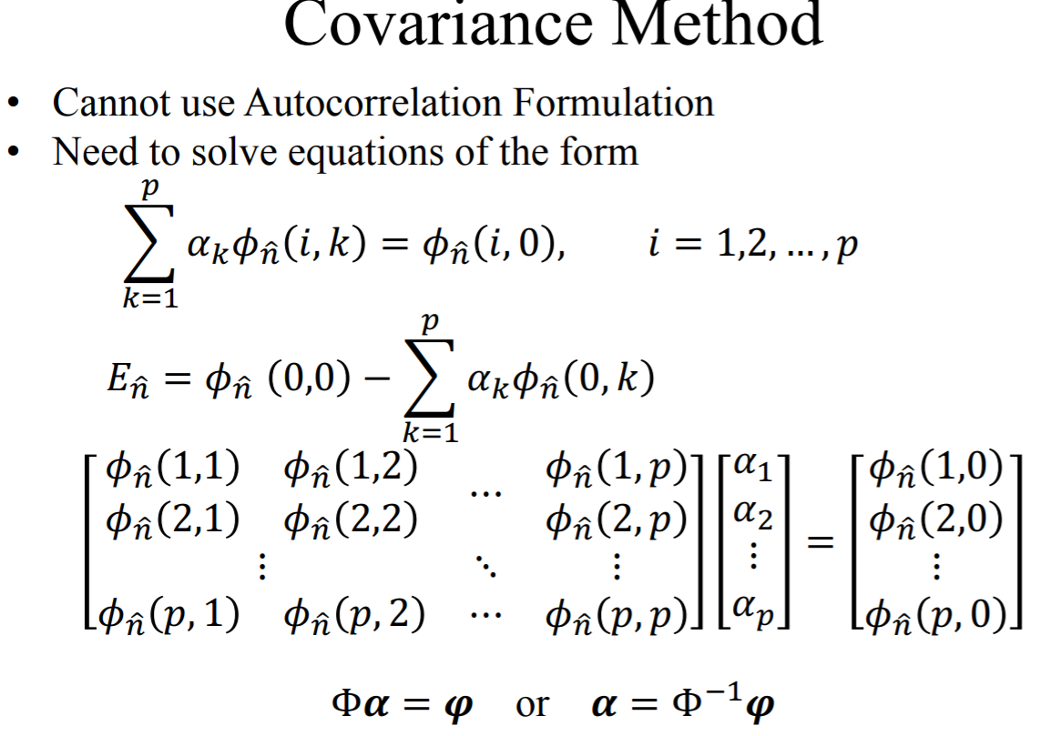

Autocorrelation Method requires tapering of the signal with a Hamming window, but it has its own algorithms to solve. Covariance method doesn’t require tapering, but its solution is somehow different.

Model Gain: $G^{2}=E_{n}$

Effects of Model Order

• The autocorrelation function, $R_{n}\left(m\right)$ of the speech segment $s_{n}[m]$, and the autocorrelation function, $R_{m}(m)$ of the impulse response, ℎ[m] , corresponding to the system function, H(z) are equal for the first p + 1 values.

• Hence, as p → ∞, the autocorrelation functions are equal

• Thus if p is large enough, the frequency response of the all-pole model, H(e^jw) , can approximate the signal spectrum with arbitrary small error

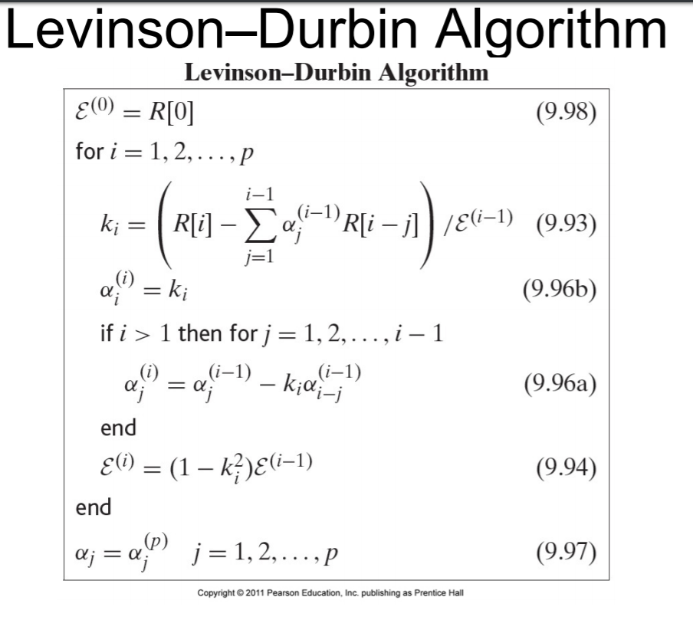

LPC equations summary

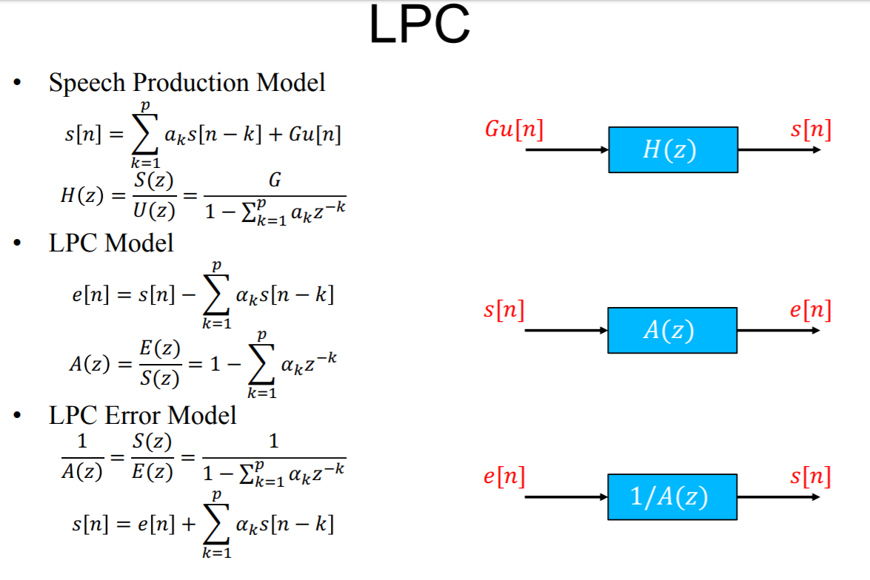

Choice of LP analysis parameters

• Need 2 poles for each vocal tract resonance below Fs/2

• Need 3-4 poles to represent source shape and radiation load

• Use values of p ≈ 10-14

Quantization:

B-bit Quantization: Use B-bit binary numbers to represent the quantized samples => 2^B quantization levels, I = B*Fs = total bit rate in bits/second. Goal of waveform coding is to get the highest quality at a fixed value of I (Kbps), or equivalently to get the lowest value of I for a fixed quality

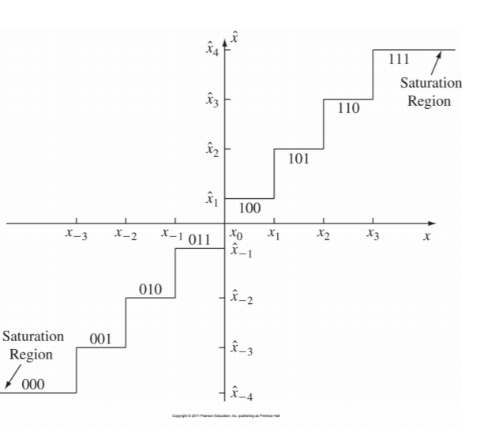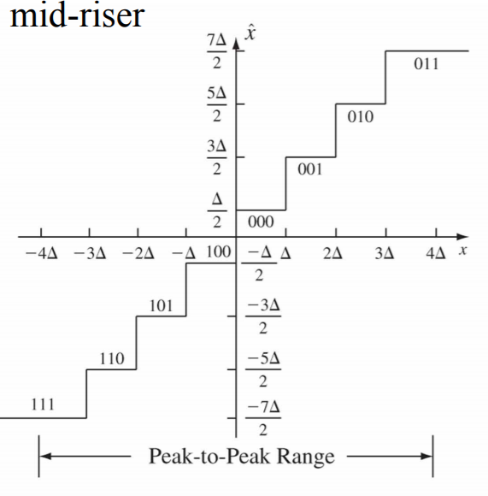

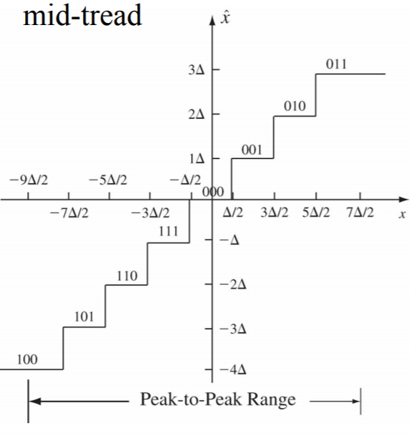

The Three Basic Problems for HMMs

Problem 1 (Evaluation): Given the observation sequence O=(o1o2…oT), and an HMM model lambda = (A,B), how do we efficiently compute P(O | lambda), the probability of the observation sequence, given the model

Problem 2 (Decoding): Given the observation sequence O=(o1o2…oT), and an HMM model lambda = (A,B), how do we choose a corresponding state sequence Q=(q1q2…qT) that is optimal in some sense (i.e., best explains the observations)

Problem 3 (Learning): How do we adjust the model parameters lambda = (A,B) to maximize P(O | lmbd)?